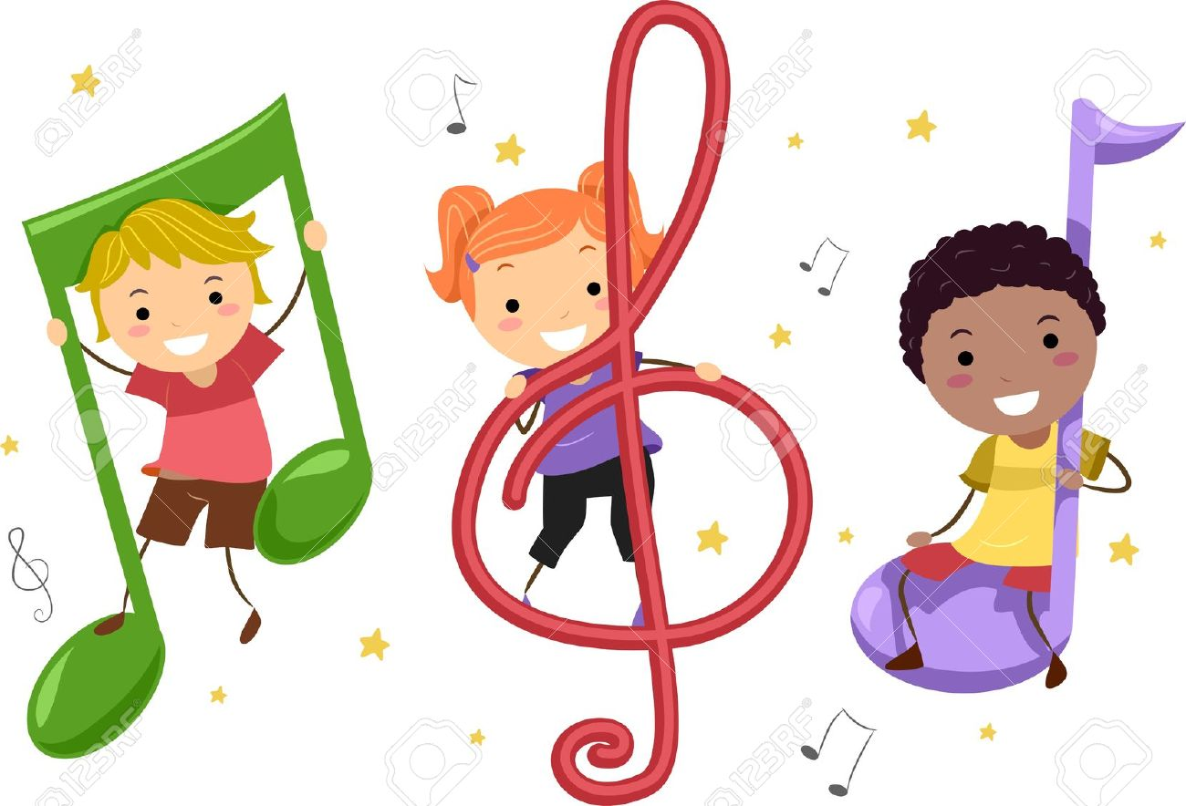 **Songs and Stories**

Every Wednesday during term time. Doors open at 8.40 for free play; songs and stories start at 9.15.

Coffee/Tea is available and a healthy snack is provided for the children.

Everyone is welcome!

 **Songs and Stories**

Every Wednesday during term time. Doors open at 8.40 for free play; songs and stories start at 9.15.

Coffee/Tea is available and a healthy snack is provided for the children.

Everyone is welcome!

 **Songs and Stories**

Every Wednesday during term time. Doors open at 8.40 for free play; songs and stories start at 9.15.

Coffee/Tea is available and a healthy snack is provided for the children.

Everyone is welcome!